OOP-LAB Task 5

Roll No: 24P-0706 | Dept: BS-CS
Name: Aazan Noor Khuwaja | Section : 2D

QNS-1:
Code: By Using Deep Copy
#include<iostream>
#include<string>
#include<cstring>
using namespace std;

class english {
char *sentence;
int size;
public:
english() : size(0) {
sentence = new char[1];
sentence[0] = '\0';
}
english(const char n[], int s) : size(s) {
sentence = new char[size + 1];
strcpy(sentence, n);
}
english(const english &e) {
cout<<"Copy constructor is called"<<endl;
size = e.size;
sentence = new char[size + 1];
strcpy(sentence, e.sentence);
}
~english() {
delete[] sentence;
}
void show() {
cout << "Name: " << sentence << endl;
cout << " Size: " << size << endl;
}
};

int main() {
english e1("Aazan", 5);
e1.show();
english e2(e1);
e2.show();
english e3(e2);
e3.show();
return 0;
}

Output: 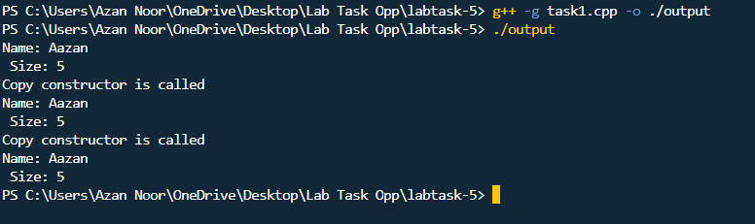
QNS-1:
Code: By Using Shallow Copy
#include<iostream>
#include<string>
#include<cstring>
using namespace std;
class english{
string sent_ence;
int si_ze;
public:
english() : si_ze(0) {
sent_ence = "";
}
english(string n){
sent_ence = n;
si_ze = strlen(n.c_str());
}
english(const english &e) {
cout<<"Copy constructor is called"<<endl;
si_ze = e.si_ze;
sent_ence = e.sent_ence;
}
void show() {
cout << "Name: " << sent_ence << endl;
cout << " Size: " << si_ze << endl;
}

};
int main() {
english e1("Aazan");
e1.show();
english e2(e1);
e2.show();
english e3(e2);
e3.show();
return 0;
}

Output:
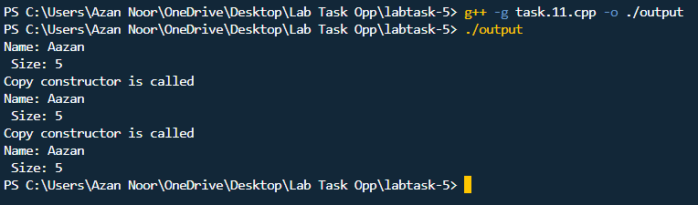

QNS-2:
Code:
#include<iostream>
using namespace std;
class serialnumber{
int serial_number;
static int count_objects ;
public:
serialnumber()
{
count_objects++;
serial_number=count_objects;
cout<<"object "<<count_objects<<" created!"<<endl;
}
static int getfun()
{
return count_objects;
}
void report_serial_numb()
{
cout<<"Serial Number is:"<<serial_number<<endl;

}

};
int serialnumber::count_objects=0;
int main()
{
serialnumber s1;
s1.report_serial_numb();
serialnumber s2;
s2.report_serial_numb();
serialnumber s3;
s3.report_serial_numb();

cout<<"The Total objects are "<<serialnumber::getfun()<<endl;
return 0;

}
Output:
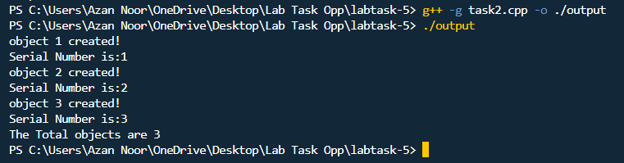

QNS-3:
Code:
#include<iostream>
using namespace std;
class time{
int hours;
int minutes;
int seconds;
public:
time():hours(0),minutes(0),seconds(0){};
time(int hours,int minutes, int seconds){
this->hours=hours;
this->minutes=minutes;
this->seconds=seconds;
}
void display()
{
cout<<"Time "<<hours<<":"<<minutes<<":"<<seconds<<endl;
}
time addtwoobjects(time t1,time t2)
{
time store;
store.hours=t1.hours+t2.hours;
store.minutes=t1.minutes+t2.minutes;
store.seconds=t1.seconds+t2.seconds;
if(store.seconds>=60)
{
store.seconds-=60;
store.minutes++;

}
if(store.minutes>=60)
{
store.minutes-=60;
store.hours++;

}
return store;
}

};
int main()
{
time t1(2,33,50);
time t2(12,24,17);
cout <<"Before Adding Objects of time :"<<endl;
t1.display();
t2.display();
time t3,t4;
t4=t3.addtwoobjects(t1,t2);
cout <<"After Adding Objects of time :"<<endl;
t4.display();
return 0;
}

Output:
